Before you start the software

1. Start by adding the migration, so that you can instantiate the tables for database
2. Open the console inside the project and run “dotnet ef migrations add initial”
3. Update the database to create the tables that you were migrating, run “dotnet ef database update”
4. Run the project,you should see the login screen

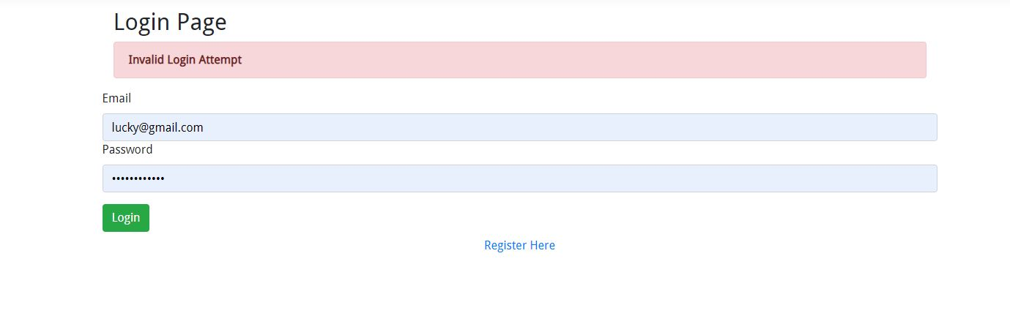

1. When you try to log in with a wrong information details, it’s going to show you this error message, then you will have to register

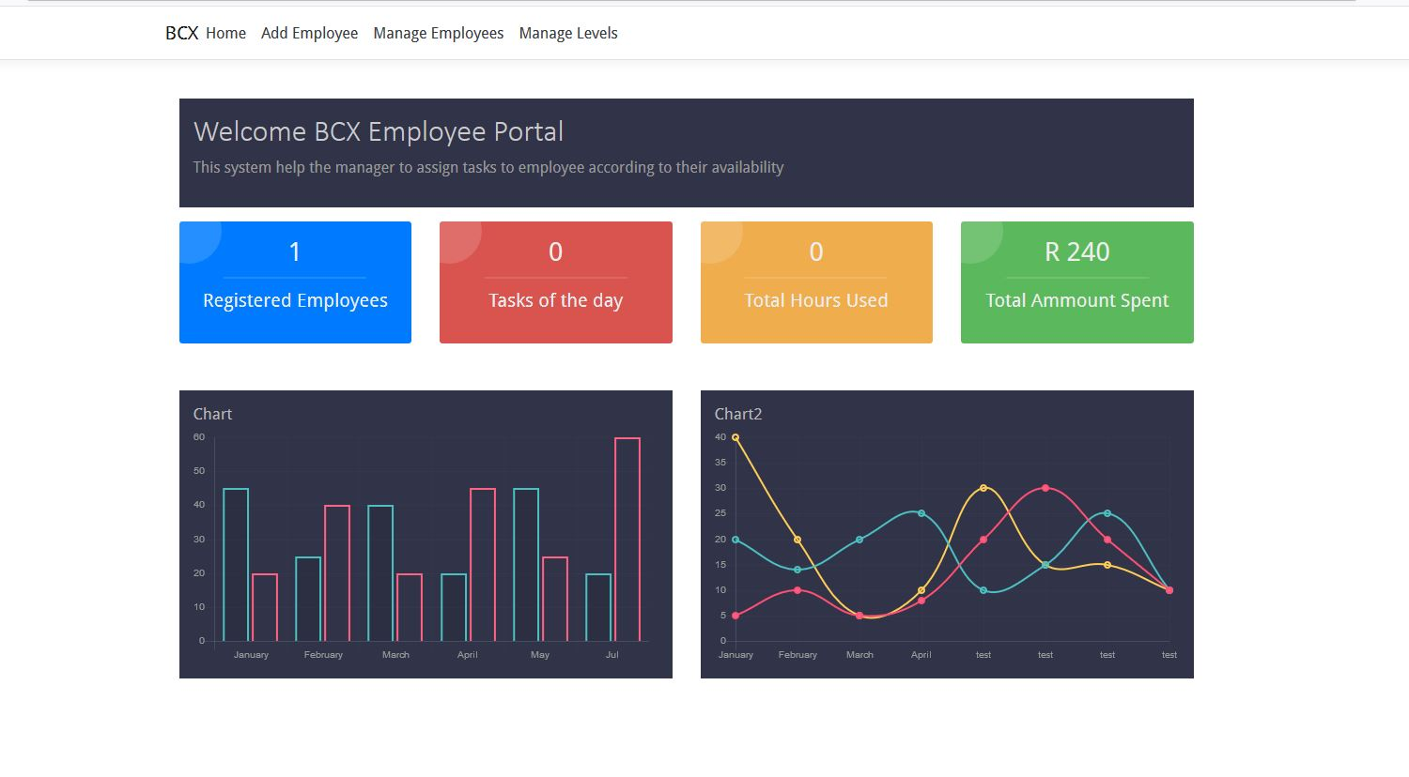

1. This will be a dashboard for a user,then you can click register Employee on top to add casual employee or manager

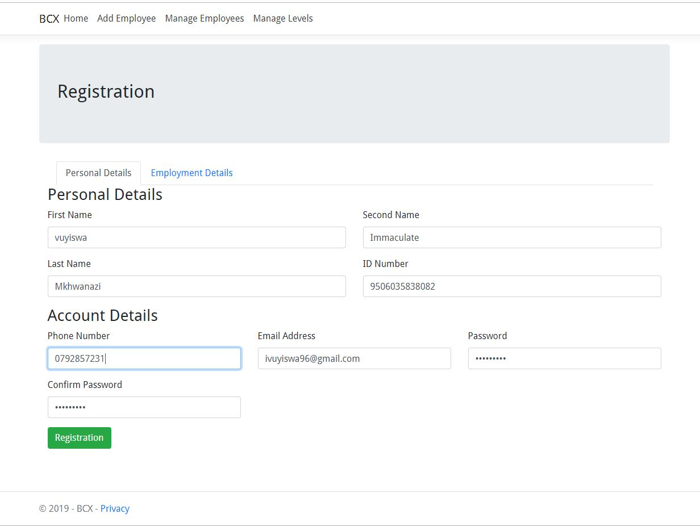

1. This is the page where you register personal account details

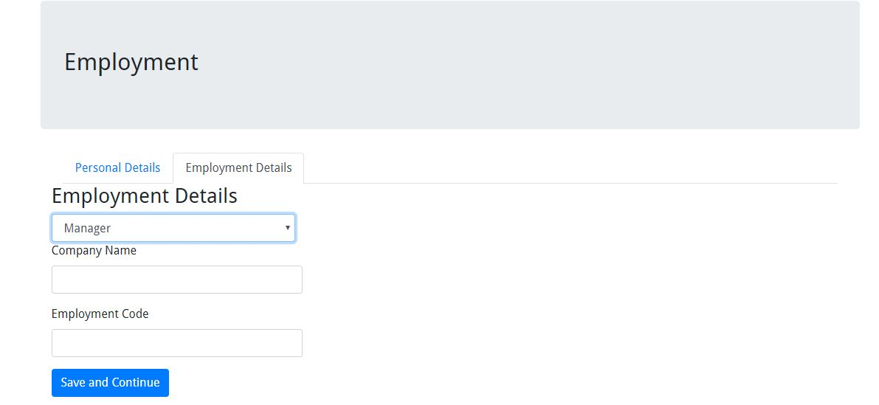

* Add yourself as a manager

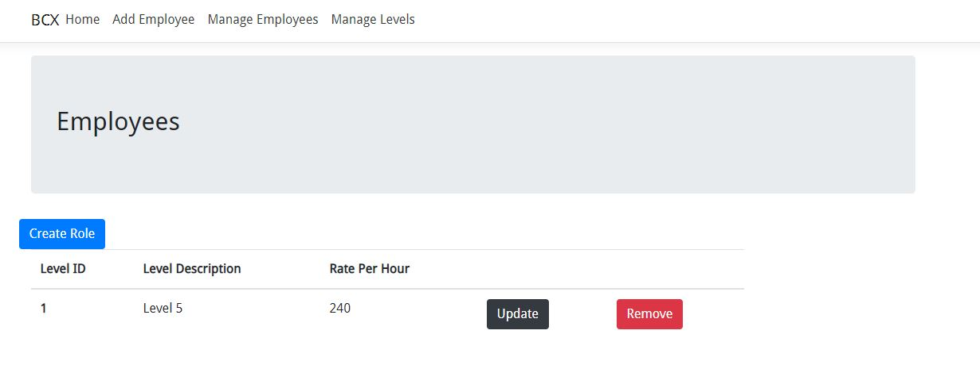

1. They you can create , Update the roles and their rates

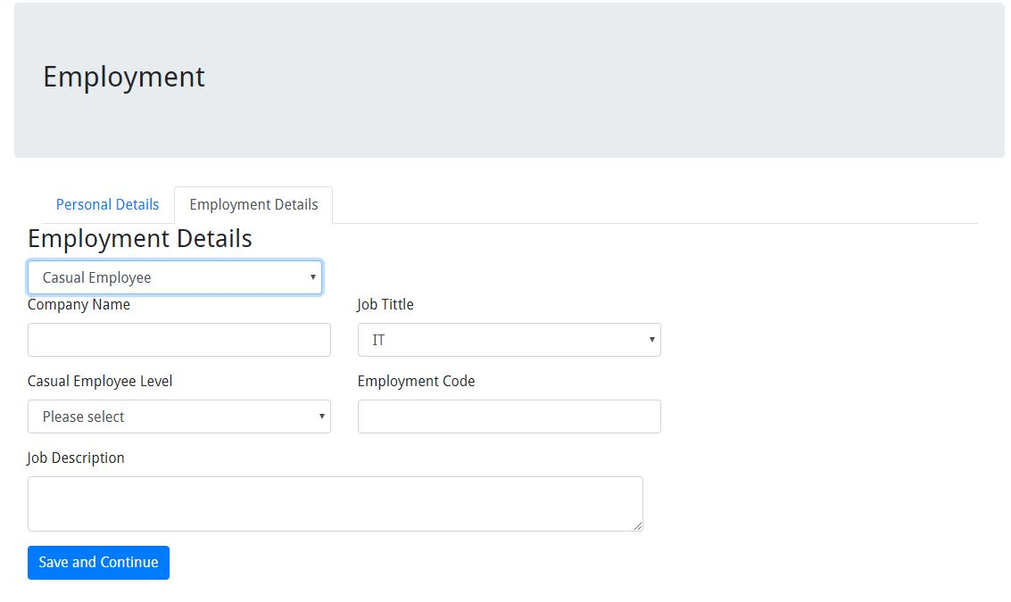

1. Now you can create an employee

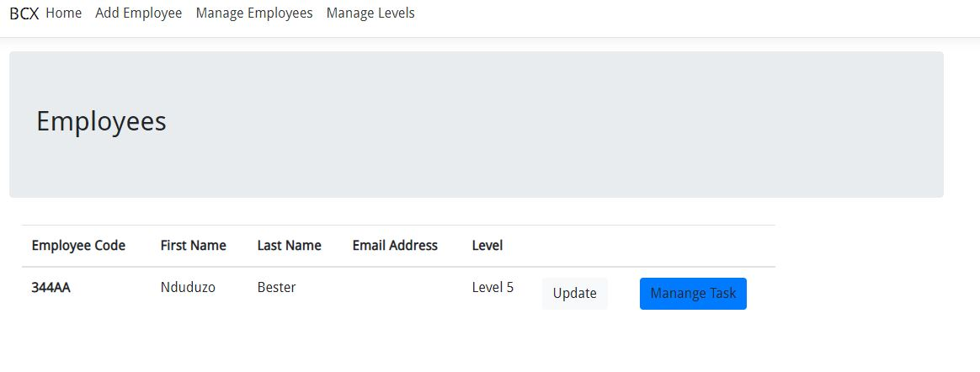

10. View the list of employees your created

11.update employee

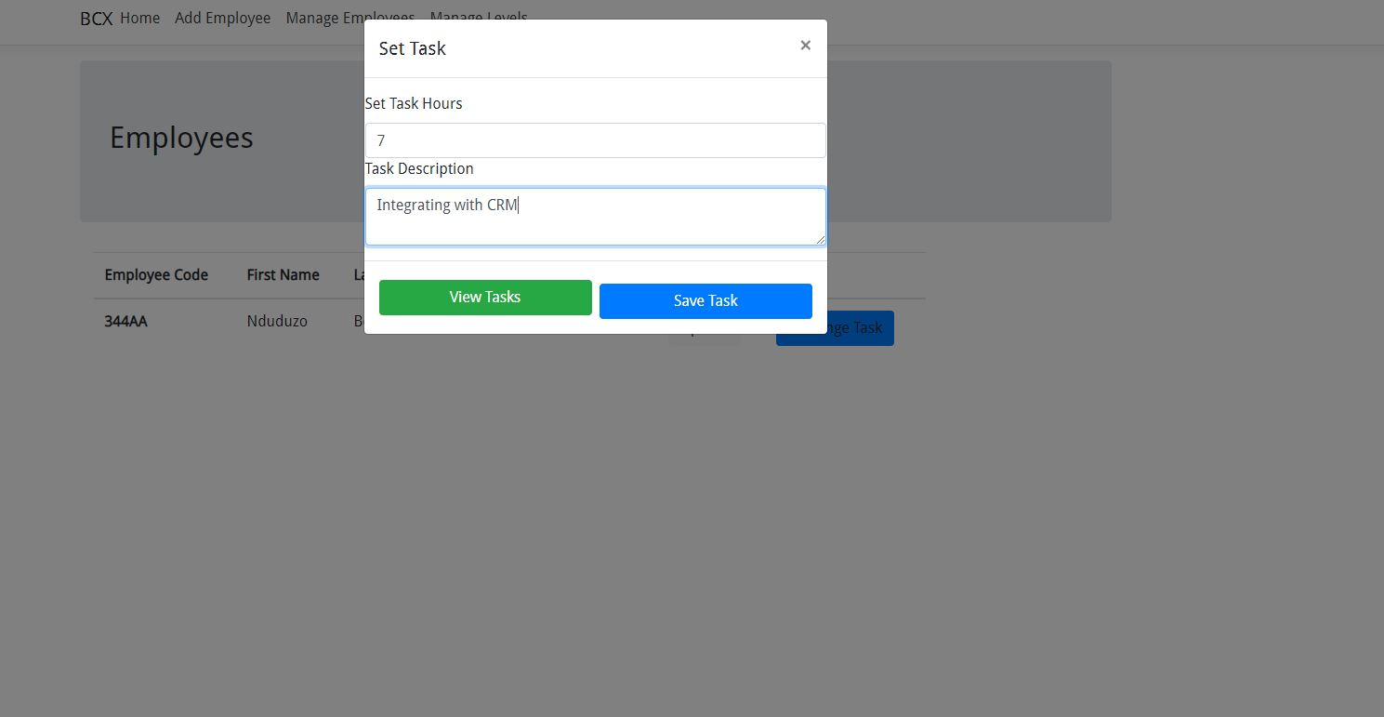

12. Create task for employee and set hours to be worked

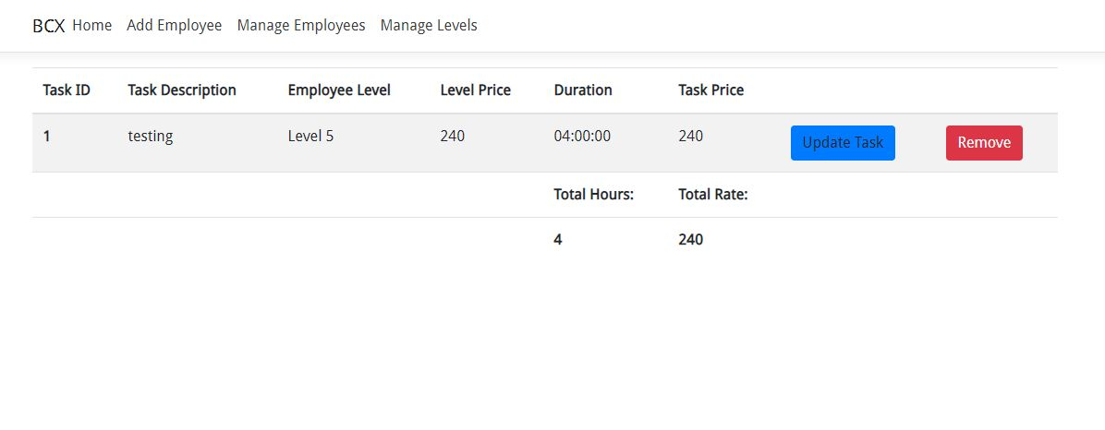

13. View the list of task, update and delete tasks